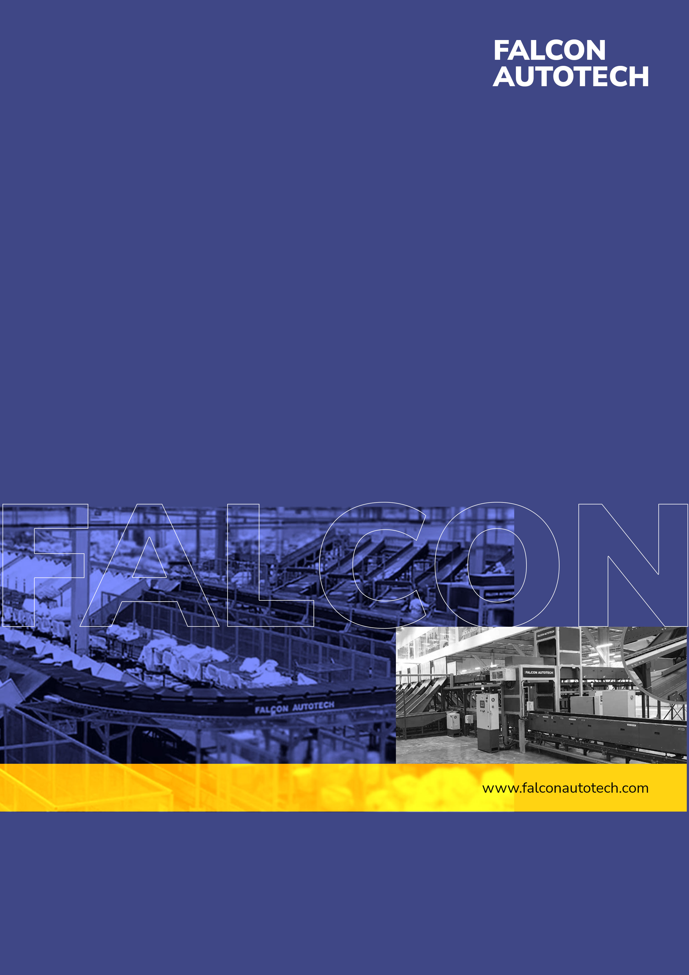
Kind Attention – Mr. Alexander Bogachev
FALCON’s Response to Yandex RFQ
for Supply of Conveyor Automation System
January 16, 2023

M/s Yandex

Offer Ref: F22-00415; Date 16.01.2022

Subject – Techno-Commercial Offer for Conveyor Automation.

Dear Team,

We are pleased to submit our Techno-Commercial Offer in response to your RFP
As you will note, we have studied your requirements in great depth and, along with the information collected during the workshops and calls with you, we have put together a detailed technical proposal laid out in various sections and sequenced to enable you to understand our proposed solution and to re-enforce our commitment to be your partner in this strategic initiative.
In subsequent sections, we have highlighted the capabilities and experiences of Falcon Autotech with sections on our Automation Technologies and references.
To conclude, I would like to add my personal commitment, on behalf of Falcon Autotech. As we move through the RFP process, please do not hesitate to contact me and my team. We will be pleased to assist you for any further information or clarifications that you might have.
tails
Contact Person : Ajay kumar
Title : Assistant Manager
Mobile : +91-9711619996
Email : ajay.kumar@falconautoonline.com
Company Details
Company Name : Falcon Autotech Pvt. Ltd.
Regd. Office : 57, Nimri Colony, Double Storey Flats, Delhi – 110052
Website : www.falconautotech.com
LinkedIn : https://www.linkedin.com/company/falconautotech/mycompany/
Table of Contents
1. Glossary 5
2. About Falcon 6
3. Handled Parcel Spectrumions Minimum Maximum 13
3.1 Product size Conveyable on the entire system. 13
3.2 Parcels/Totes to be loaded on Conveyor/Sorter shall have the following characteristics: 13
3.3 Parcel not loadable on the system 14
4. Proposed System Description 15
4.1 Objective 15
4.2 Summary of the System. 15
5. Layout View 16
6. System Components 17
6.1 Powered Roller Conveyor 17
6.2 Accumulation Conveyor 18
6.3 PVC Belt Conveyor 19
6.4 Powered Roller Turns & Merges 20
6.5 Pop Up sorter– Falcon 21
7. Proposed System Technical Details/BOM 22
8. Falcon’s WCS CONTROLIT 23
9. Key Component Makes 24
10. Safety 24
10.1 Push Buttons 24
11. Automation Management System (AMS) 25
11.1 Issue Logging 25
11.2 Preventive Maintenance Check List 26
11.3 Predictive Maintenance 26
11.4 Training Portal 27
11.5 Operational Analysis 27
12. Commercial Terms 28
12.1 Price Sheet 28
12.2 Payment Terms 29
12.3 Delivery schedule. 29
13. Warranty Period 29
14. Exclusions 30

Glossary
S. No. | Term | Description
1 | RFP | Request For Proposal
2 | PPH | Parcels Per Hour
3 | DBO | Damaged Barcode
4 | MEZZ | Mezzanine
5 | AC | Alternating Current
6 | DC | Direct Current
7 | PLC | Programmable Logic Controller
8 | IT | Information Technology
9 | BOQ | Bill Of Quantity
10 | I/O | Input/ Output
11 | PDP | Power Distribution Panel
12 | PC | Personal Computer
13 | UPS | Uninterrupted Power Supply
14 | SWEDI | Swivel Wheel Divert

About Falcon
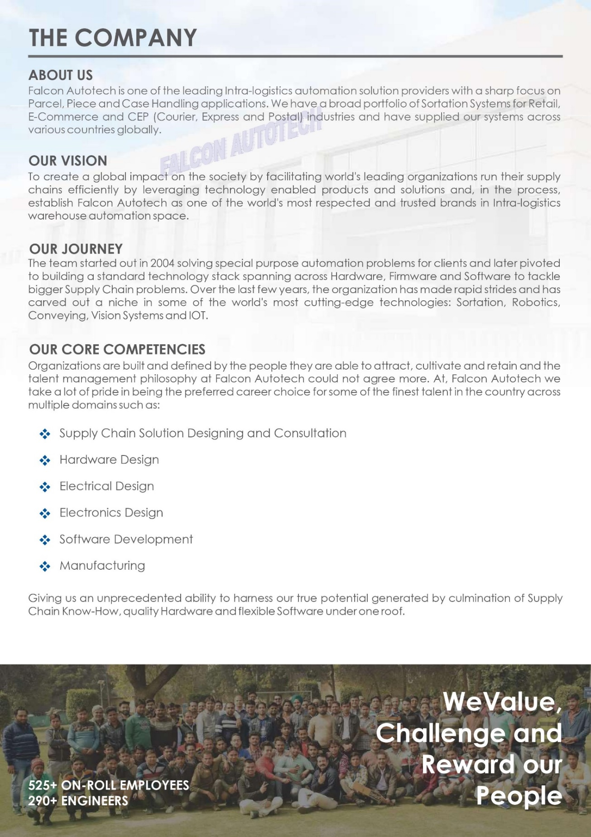
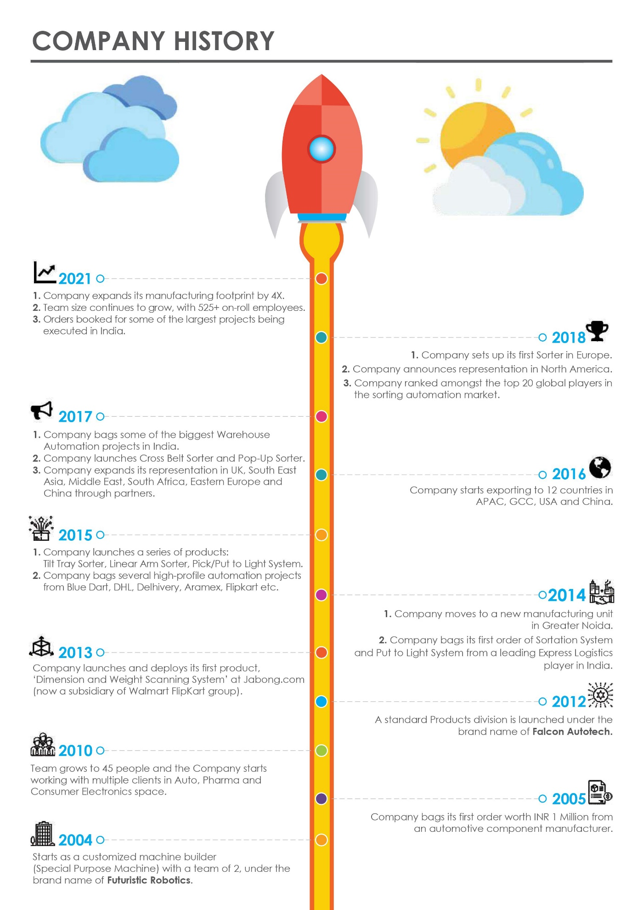
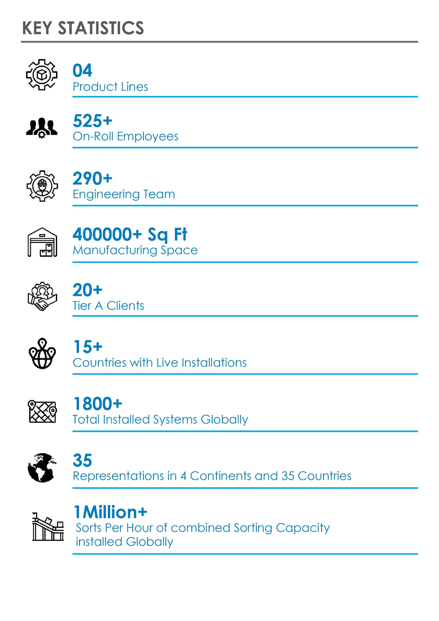
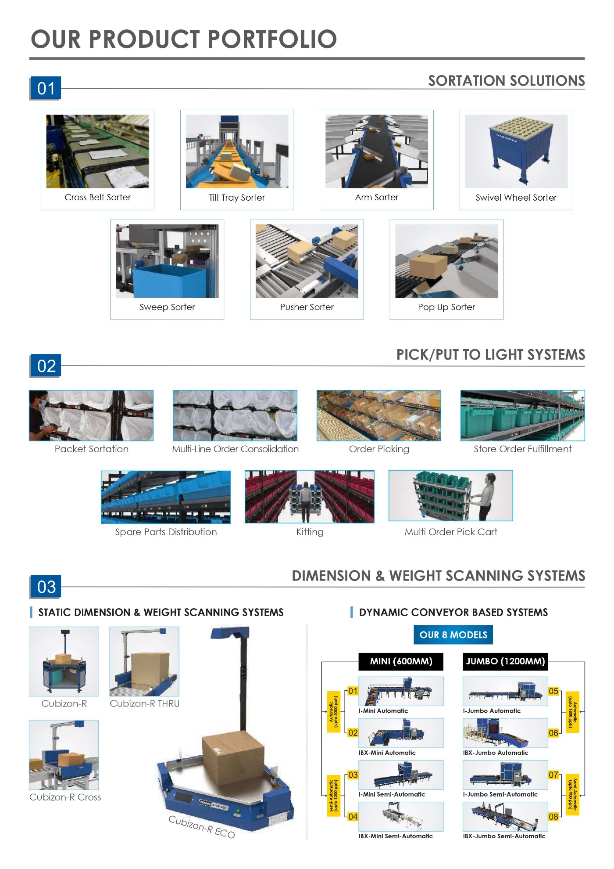
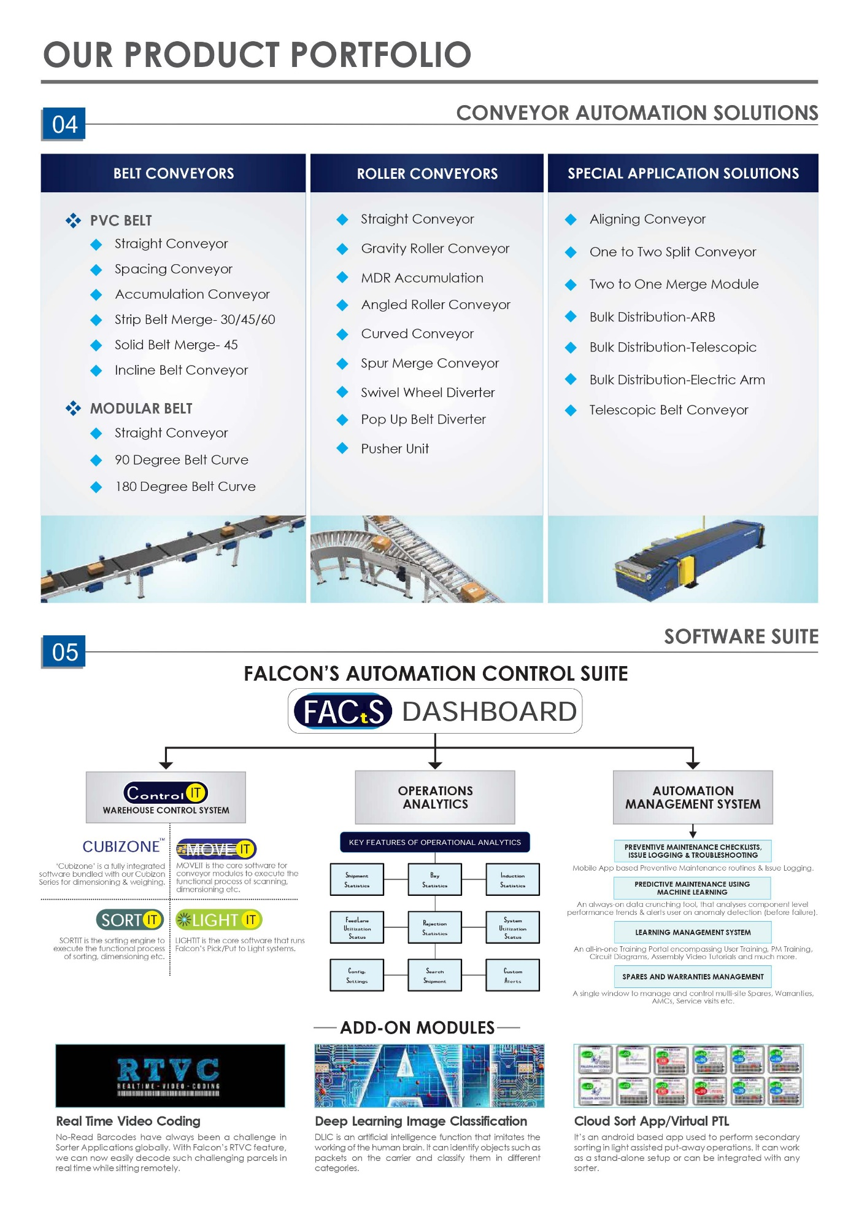
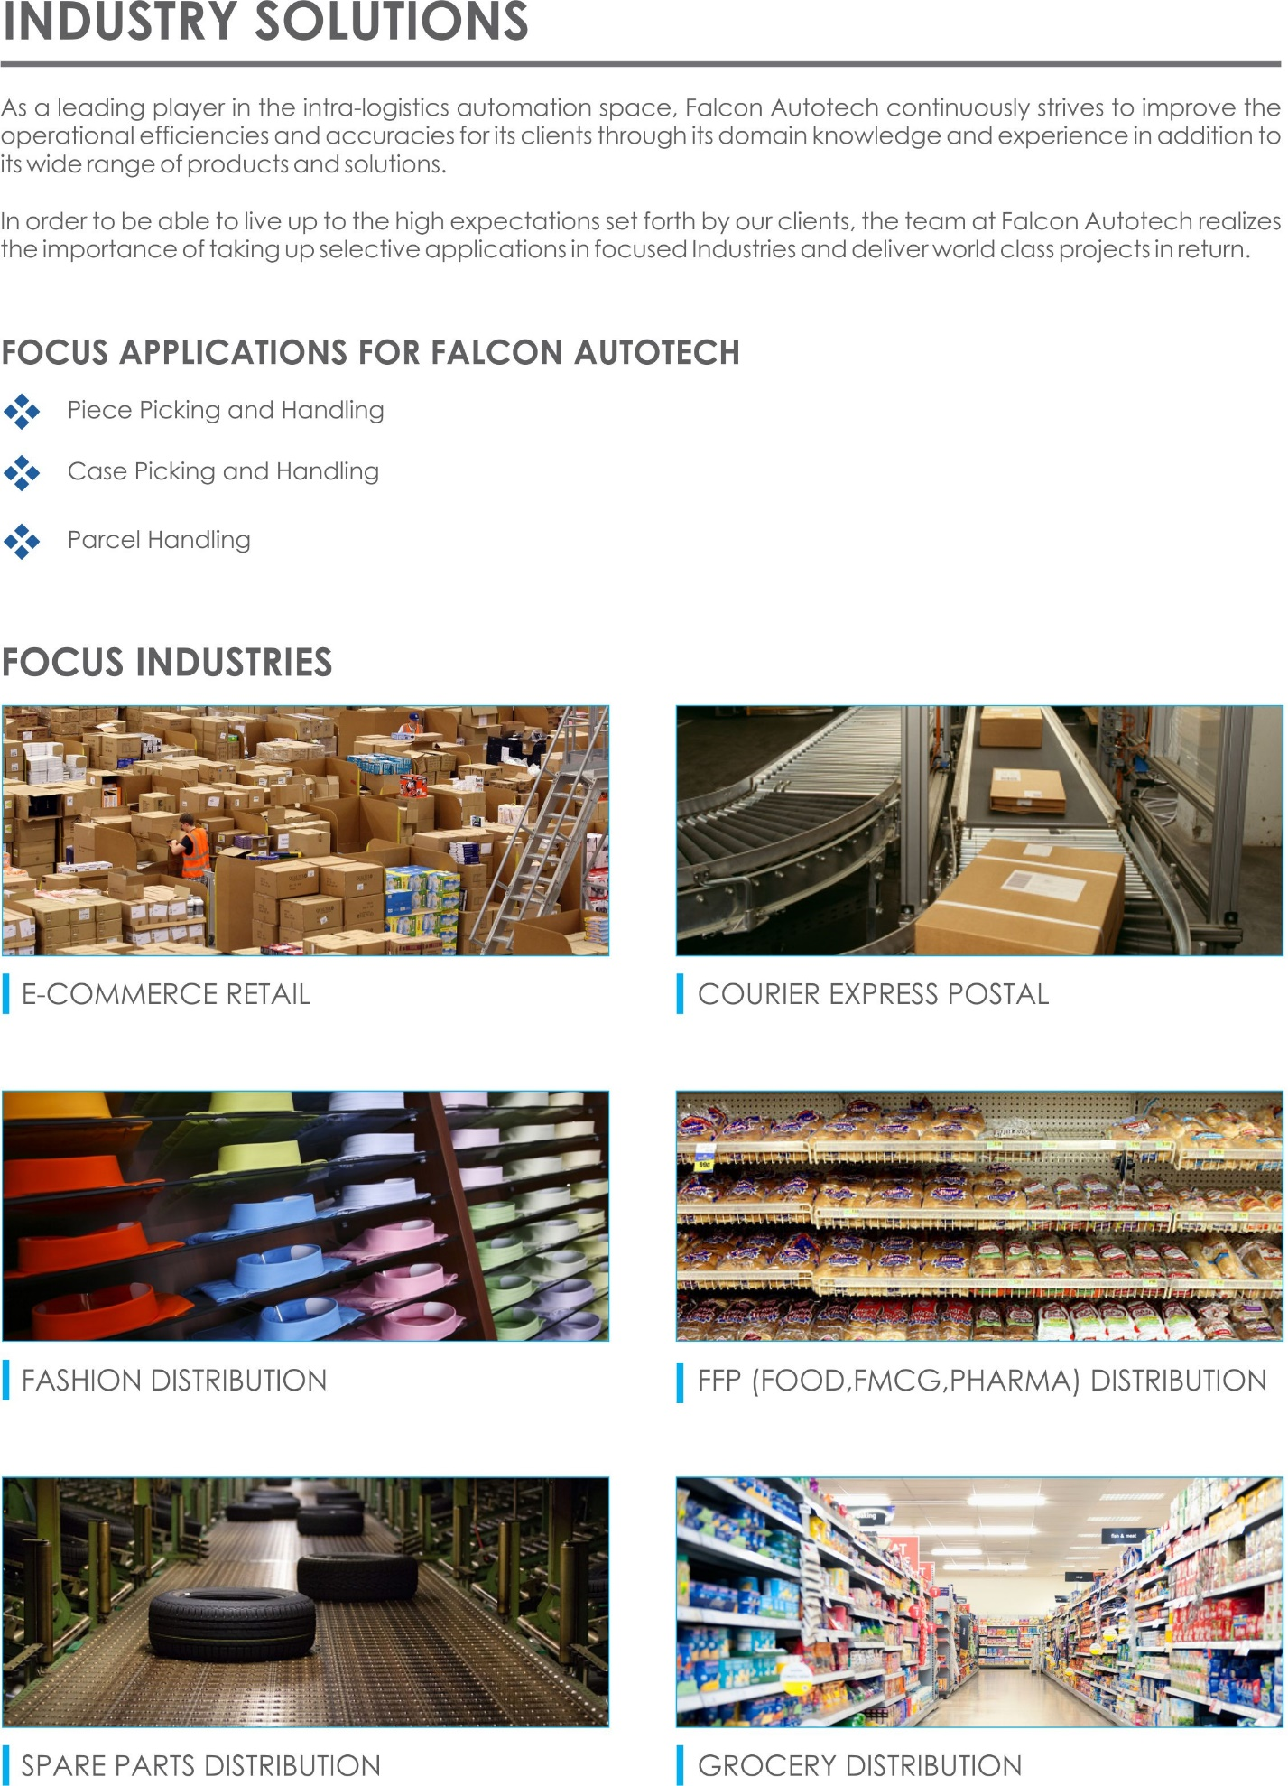
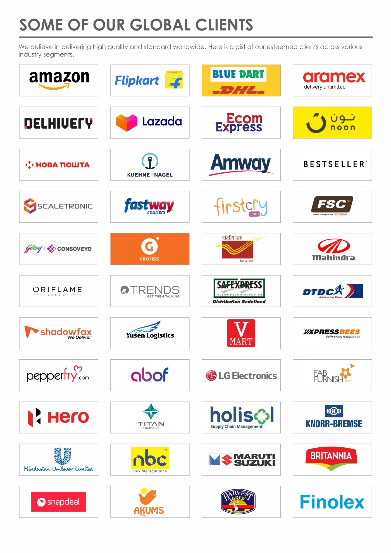

Handled Parcel Spectrumions Minimum Maximum

Product size Conveyable on the entire system.
Totes Size.
Max Length | mm | 600
Max Width | mm | 400
Max Height | mm | 450
Max Weight | Kg | 03

Parcels/Totes to be loaded on Conveyor/Sorter shall have the following characteristics:

- Centre of Gravity of items must not move during conveyance or sorting.
- Item must not have magnetic content; otherwise behaviour of parcel cannot be guaranteed.
- Liquid or fragile material, to avoid breaking, spillage or leakage, such as wine bottles, metal cans of paint are designated as non- conveyable items.
- Parcels shall be perfectly and safely packaged: protrusion or open surfaces are not allowed.
- Plastic ropes shall be perfectly adherent to the surface of the package.
- All items with the risk of being damaged during the transport on an automatic conveying/sorting system or damaging the system. They must be robust enough to avoid disintegration of container material and loose of contents in the conveying/sorting process.
- Item packaging shall have enough grip to be handled on the belts during the acceleration and
referencing phases.
- Items shall not have slippery surfaces and must be able to withstand acceleration of the items on the belt during the start-stop phases (accelerations up to 0.5 g shall be assured without any sliding or tumbling of the items on the belt conveyor).
- The parcels must have at least one flat and regular surface providing enough stability during conveyance.
- All shapes are permitted except spherical, cylindrical, or alike unstable items & shapes.
- All usual packaging materials are permitted (including paper, carton, plastics, plastic foil, rope, tape, textile, and wood)

Parcel not loadable on the system
All products that are not within the range as described here, are considered non- conveyable products, and must be taken out of the main sorter flow by the operators.

- Unstable items with a risk to roll or tumble on the sorting system, such as spherical or cylindrical items
- Items that have a spherical or cylindrical shape.
- Items that are packed in material that can damage the conveyors or the sorter.
- Items that have sharp points (e.g. Nails) or sharp edges, that can damage the conveyors or the sorter.
- Fragile parcels with contents not sufficiently secured
- Items that have been classified as dangerous are designated.
- Wet items are designated.
- Items with anti-slip treatment.
- Items with protruding parts.
- Items with sharp edges.
- Inadequately packed items that could be damaged during automatic transportation.
- Electrostatically loaded items.
- Loose parts on loads and load carriers, such as adhesive tape, stickers, slips of paper, straps, wrap foil etc. are designated as non- conveyable items.

Proposed System Description

Objective
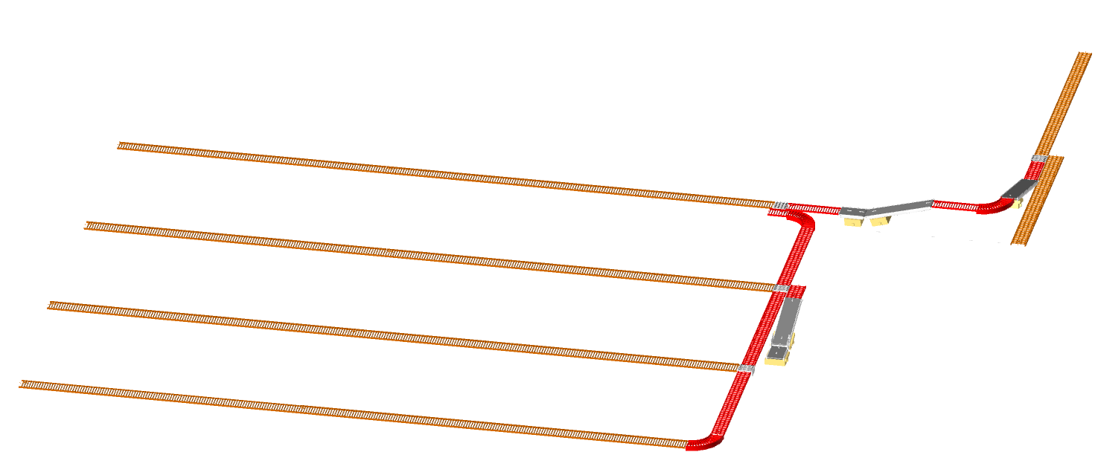
The purpose of this proposal is to present the design, manufacturing, installation, commissioning, testing and acceptance testing of the complete automation system to handle Totes as per specifications shared by Yandex.

Summary of the System.
The Proposed system is for empty totes which are coming from the different floors. System will be installed above the existing set up of full totes. One buffer zone is provided at the ground floor and rest of the totes will be diverted to the main line for distribution of empty totes as per the operator availability. Totes will be diverted with the help of Pop up sorter/ Diverter.
The proposed solution has the following advantages:
- High operational throughput up to 1500 PPH
- Easily integrated with existing system.
- Low occupancy of floor space in the building
- FALCON’s system can adapt with changing business requirements by adjusting its speed to match the operational throughput requirement, thereby leading to Power Savings and reduced system Wear & Tear

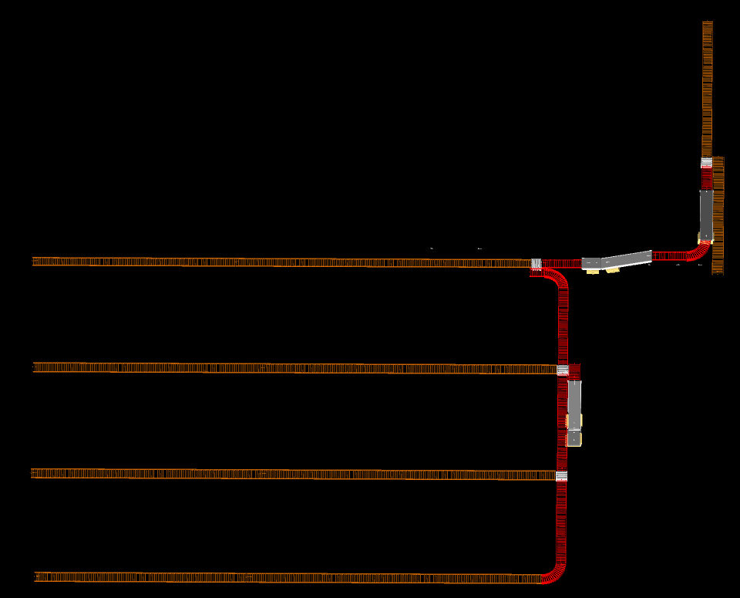
Layout View
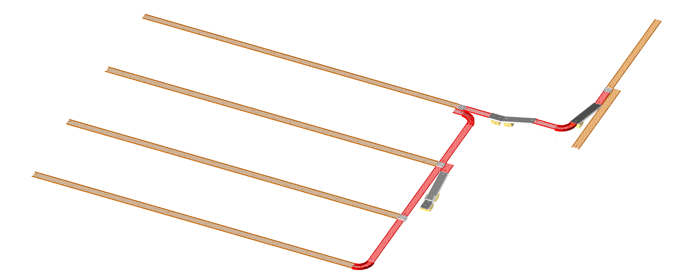
Plain View
Isometric View

System Components

Powered Roller Conveyor
Falcon’s Roller conveyors are highly energy efficient and require negligible maintenance leading to very minimal Operating costs and thus lower cost of ownership.
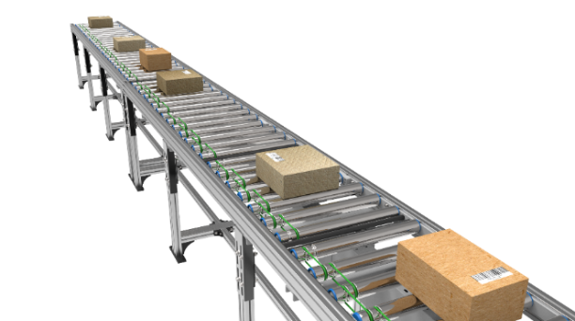
Some Salient Features of Falcon’s roller conveyor:
- Low Noise
- Maximum uptime.
- Minimal maintenance
- High safety standards.
- Fastest ROI
- Comes with MS frame.

Specification | UOM | Remark
Manufacturer Name | Name | Falcon Autotech
Material of Roller | Type | MS Rollers with Zinc Plating
Overall Width | mm | 600
Conveyor Height | mm | Variable as per design shared
Drive Power Rating | Watt | 40
Type of Motor | Type | DC Rollers (MDR)
Type of Drive System | Type | Poly V Belt Drive
Insulation Class | Type | Yes
Conveyor Speed | m/s | Variable speed to meet TPH requirements
Load capacity/unit length of Conveyor | kg/m | 50
Roller Span | mm | Variable
Roller Diameter | mm | 50
Pitch of Rollers | mm | 124
Type of Mounts | Type | Fixed Heights Legs with required Grouting Provisions

Accumulation Conveyor
Falcon’s Accumulation conveyors are highly energy efficient and require negligible maintenance leading to very minimal Operating costs and thus lower cost of ownership.
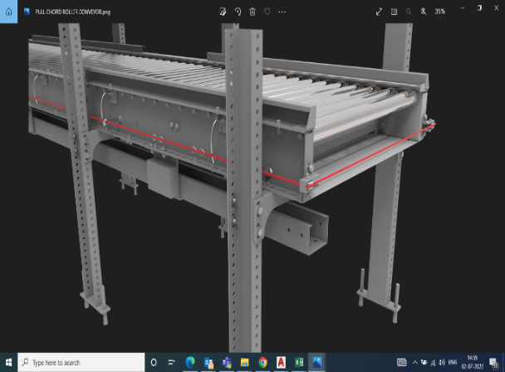
Some Salient Features of Falcon’s accumulation conveyor:
- Low Noise
- Maximum uptime.
- High safety standards.
- Fastest ROI
- Comes with MS frame.

Specification | UOM | Remark
Manufacturer Name | Name | Falcon Autotech
Material of Roller | Type | MS Rollers with Zinc Plating
Overall Width | Mm | 600 /700
Conveyor Height | Mm | As per Layout requirement
Drive Power Rating | Watt | 40
Type of Motor | Type | DC Rollers (MDR)
Type of Drive System | Type | Round/Poly V Belt Drive
Insulation Class | Type | Yes
Conveyor Speed | m/s | Variable speed to meet TPH requirements
Load capacity per unit length of Conveyor | kg/m | 50
Roller Span | Mm | Approx. 600
Roller Diameter | Mm | Approx. 50
Pitch of Rollers | Mm | 75
Zone Length | Mm | 680
Type of Mounts | Type | Fixed Heights Legs with Grouting Provisions
Type of Guides | Type | Steel guides at 50mm height basis the position of conveyor on both sides from Conveyor Belt Surface.

PVC Belt Conveyor
Falcon’s Belt Conveyors are modular & robust in design. MS profile is used to build conveyor frame.
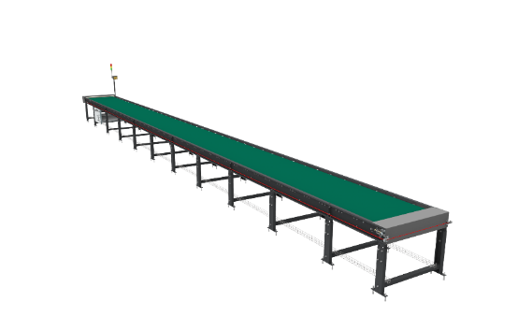
Some Salient Features of Falcon’s Belt conveyor:
- Low Noise
- Maximum uptime.
- Minimal maintenance
- High safety standards.
- Fastest ROI.

Specification | UOM | Remark
Manufacturer Name | Name | Falcon Autotech
Material of Roller | Type | MS Rollers with Zinc Plating
MOC of Belt | Type | PVC
Belt Thickness | mm | 3
Belt Finish | Type | Matt Finish
Belt width | mm | 800
Belt Joint Type | Type | Vulcanized, Endless Belts
Belt Make/Model No. | Make | FORBO/DERCO
Chassis | mm | MS, 3mm Thick, Powder Coated-75 Microns
Idler Roller Pitch on running side (Top) | mm | 480
Idler Roller Pitch on return side (Bottom) | mm | 1200
Idler Roller Specs | Spec | Dia.50.8, shaft-12 mm, bearing-6301
End Rollers | Spec | Dia 81.2 x 2.85 Thick, 30mm Shaft Dia, & Bearing Size-UCFH206D1, MOC-EN9, Zinc Plated -25 microns
Drive Rollers | Spec | OUTER Dia 178 PIPE Dia 168x5 Thick, 40mm Shaft Dia, & Bearing Size-UCF208D1, MOC(SHAFT)-EN9, NEOPRENE RUBBER COATING
Tensioning Rollers | Spec | Dia 81.2 x 2.85 Thick, 25mm Shaft Dia, & Bearing Size-UCT205D1, MOC-MS, Zinc Plated -25 microns
Take Up Rollers | Spec | Dia 81.2 x 2.85 Thick, 25mm Shaft Dia, & Bearing Size-6305-LLU, MOC-MS, Zinc Plated -25 microns
Type of Drive | Type | Rubberized
Angle of wrap/Contact - Belt with Drive pulley | Deg | >180 deg
Motor Shaft | MOC | EN9 Shaft material,
Conveyor Under guarding | Spec | MOC-MS, 0.8 to 1mm thickness, Steel Stiffeners at every 600mm to avoid the sagging due to self-weight
Load capacity per unit length of Conveyor | kg/m | 50
Type of Guides | Type | Steel guides at 50mm/400mm height basis the position of conveyor on both sides from Conveyor Belt Surface.
Drive Power Rating | kW | Motor Rating depends on Length of the Conveyor
Type of Motor | Type | AC Geared Motor
Type of Drive System | Type | Direct Shaft Mounted Motor/ Flange Mounted
Type of Drive | Type | Chain drive/Torque Arm type
Gear Motor | make | Sew/Nord
Drive | make | Lenze/Siemens/Omron/Allen Bradly
Insulation Class | Type | Yes
Conveyor Speed | m/s | Variable speed to meet TPH requirements
Type of Mounts | Type | Fixed Heights Legs with Grouting Provisions

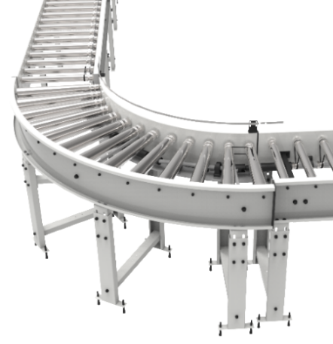
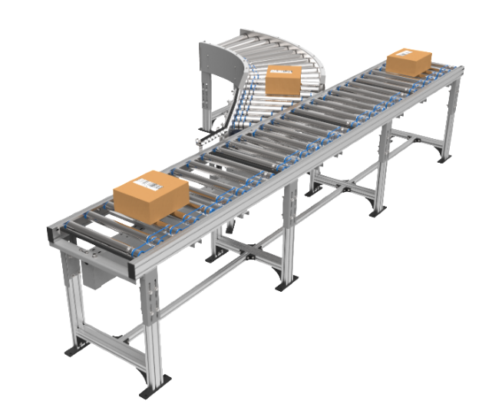
Powered Roller Turns & Merges

Pop Up sorter– Falcon
Falcon’s Belt Popup device is used in system for 90° transfer of products.
Some Silent Features of Falcon’s Pop Up diverter:
- Low Noise
- Maximum uptime.
- Electric based popup.
- Minimal maintenance
- High safety standards

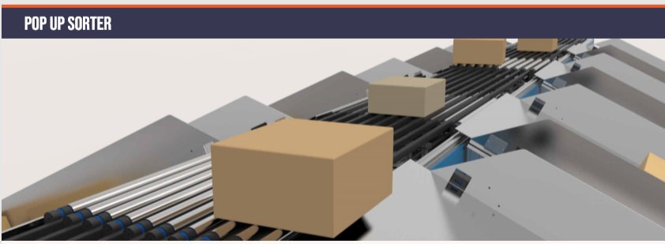

Specification | UOM | Remark
Manufacturer Name | Name | Falcon Autotech
Type - Equipment | Type | Merge/Sorting
Type - Operation | Type | Sorting / diverting
Mechanism for Swivel | Type | Electric servo motor
Roller drive | kW | Pop Up rollers
Roller pitch (L x W) | Type | 110 x 120
Max. product weight (kg/m2) | kg/m2 | 5 Kg
Throughput | PPH | 1500
Type of Mounts | Type | Fixed Heights Legs with Grouting Provisions

Proposed System Technical Details/BOM
S No. | Name | ANGLE | Width | EL_1 | EL_2 | Conveyor Length (m) | Set | UOM
1 | FAL_RC 1 | 0 | 600 | 700 | 700 | 2.0 | 1.0 | Mtrs
2 | FAL_PC 2 | 18 | 800 | 700 | 2500 | 5.8 | 1.0 | Mtrs
3 | FAL_RC_90_Degree | 0 | 600 | 2500 | 2500 | 0.0 | 1.0 | Set
4 | FAL_RC_90_Degree | 0 | 600 | 1600 | 1600 | 0.0 | 2.0 | Set
5 | FAL_RC 1 | 0 | 600 | 2500 | 2500 | 2.3 | 1.0 | Mtrs
6 | FAL_PC 2 | -15 | 800 | 2500 | 1600 | 3.5 | 1.0 | Mtrs
7 | FAL_PC 1 | 0 | 800 | 1600 | 1600 | 1.2 | 1.0 | Mtrs
8 | FAL_PC 2 | -15 | 800 | 1600 | 700 | 3.4 | 1.0 | Mtrs
9 | FAL_PC 1 | 0 | 800 | 600 | 600 | 1.2 | 1.0 | Mtrs
10 | FAL_RC 1 | 0 | 600 | 1600 | 1600 | 2.7 | 1.0 | Mtrs
11 | FAL_RC 1 | 0 | 600 | 1600 | 1600 | 1.0 | 1.0 | Mtrs
14 | FAL_RC 1 | 0 | 600 | 1600 | 1600 | 6.5 | 1.0 | Mtrs
15 | FAL_RC 1 | 0 | 600 | 1600 | 1600 | 8.3 | 1.0 | Set
16 | FAL_RC 1 | 0 | 600 | 1600 | 1600 | 7.1 | 1.0 | Mtrs
17 | FAL_RC 1 | 0 | 700 | 1600 | 1600 | 1.4 | 1.0 | Mtrs
18 | FAL_RC 1_Accmulation_roller_Conveyor | 0 | 700 | 1600 | 1600 | 20.0 | 3.0 | Mtrs
19 | FAL_RC 1_Accmulation_roller_Conveyor | 0 | 700 | 1600 | 1600 | 14.3 | 1.0 | Mtrs
20 | FAL_RC 1_Accmulation_roller_Conveyor | 0 | 600 | 1600 | 1600 | 13.8 | 1.0 | Mtrs
21 | FAL_RC 1_Accmulation_roller_Conveyor | 0 | 700 | 1600 | 1600 | 15.5 | 1.0 | Mtrs
22 | FAL_RC 1_Accmulation_roller_Conveyor | 0 | 700 | 1600 | 1600 | 15.5 | 1.0 | Mtrs
23 | FAL_RC 1_Accmulation_roller_Conveyor | 0 | 600 | 700 | 700 | 11.6 | 1.0 | Mtrs
24 | FAL_RC 1_Accmulation_roller_Conveyor | 0 | 700 | 700 | 700 | 10.0 | 1.0 | Mtrs
25 | FAL_RC 1_Accmulation_roller_Conveyor | 0 | 600 | 1600 | 1600 | 20.0 | 1.0 | Mtrs
26 | Pop Up sorter / Diverter |  |  |  |  |  | 05 | Qty

Falcon’s WCS CONTROLIT
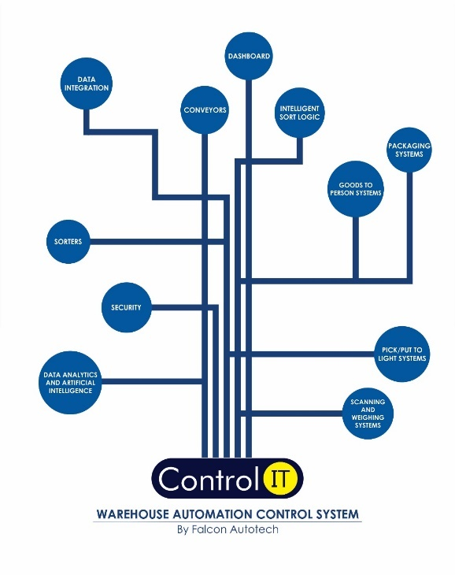
Key Values
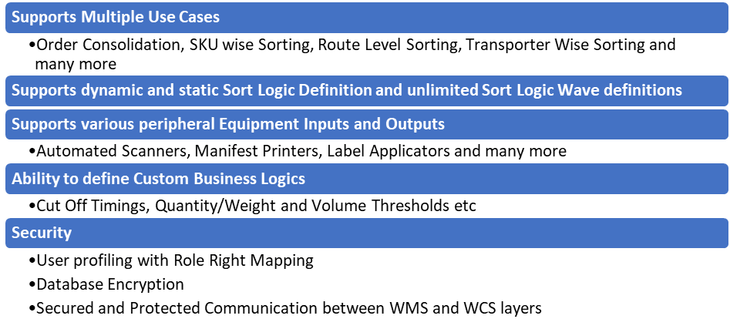
Supported Protocols
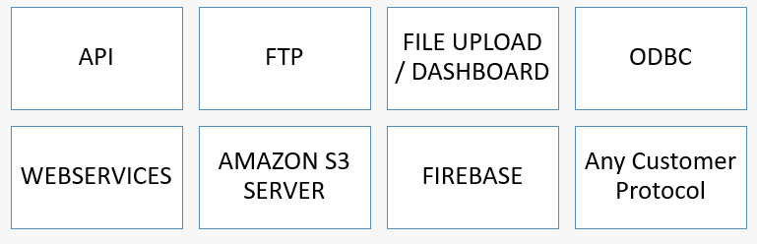

Key Component Makes
Component | Make
PLC & RIO | Siemens/Omron
VFD | Siemens/Omron/Lenze/AB
Ethernet switch | Siemens/Phoenix Contact
SMPS | Omron/Selec/Meanwell
Line chokes | EMIS/GURU NANAK ELE.
Slim relays | Phoenix contact
Terminals | Wago
Phase failure relay | Selec
Tower lamp + Hooter | Leuze
Utility switch & socket | Anchor
Switchgear | Schneider
Main load break switch (CP) | Schneider
Geared Motors | SEW
MDR | Pulse
Roller conveyor | Interroll / Pulse
Cameras | Cognex/Sick
Pop Up | Pules
Weighing Scale | Mettler Toledo/Bizerba

Safety

Push Buttons
Emergency Push Buttons will be provided at all the points of human interaction on the system.
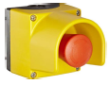

Automation Management System (AMS)
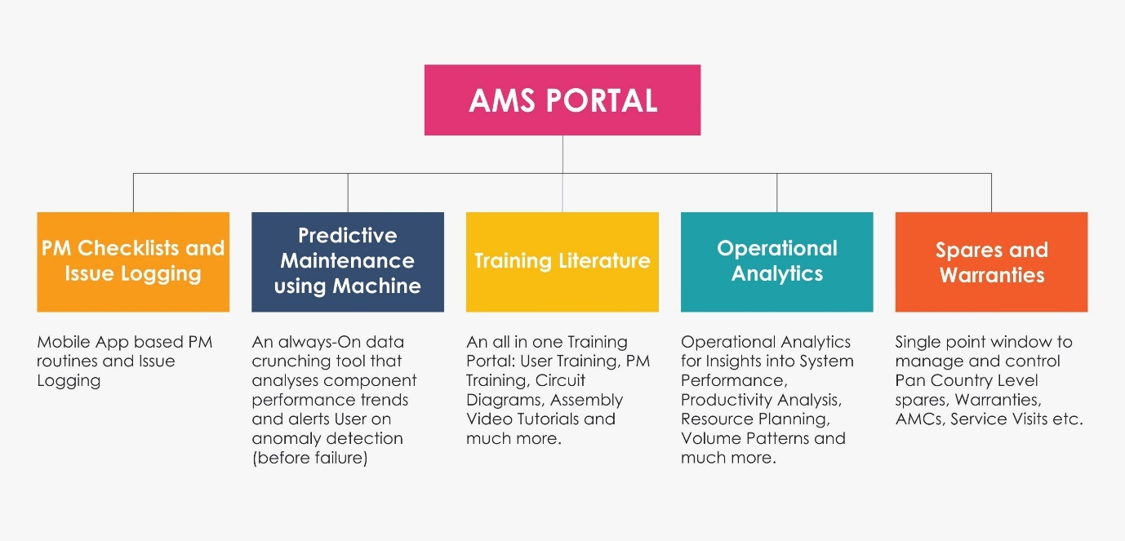

Issue Logging

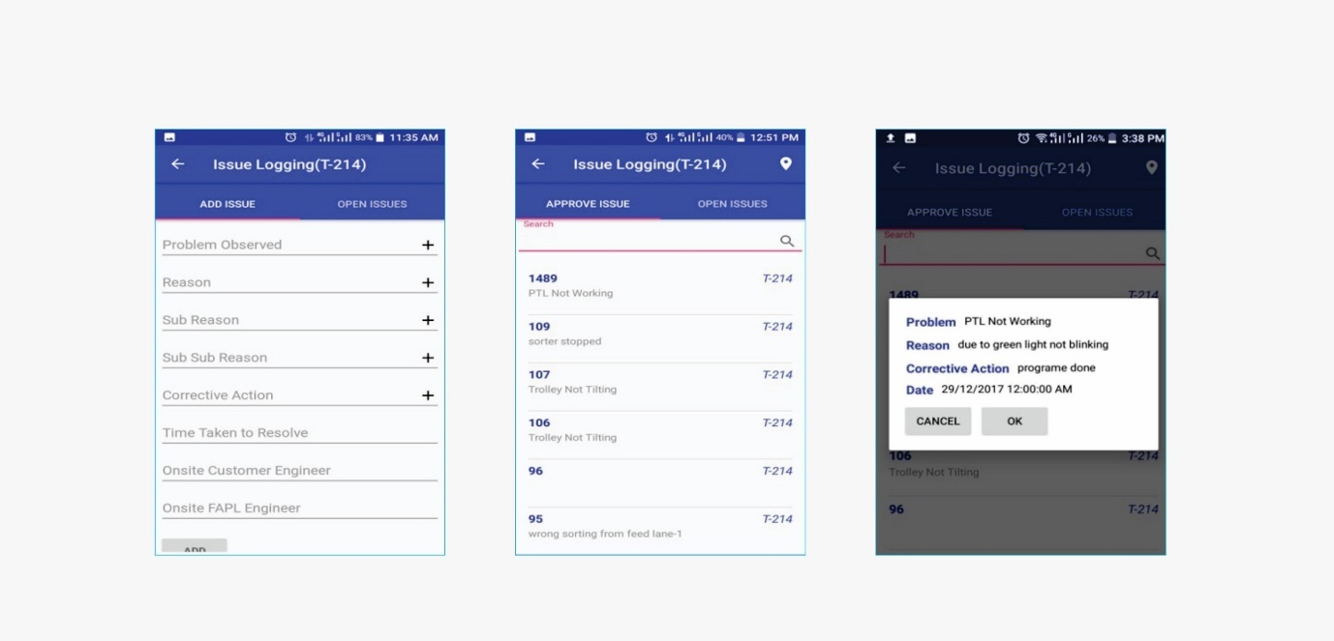

Preventive Maintenance Check List
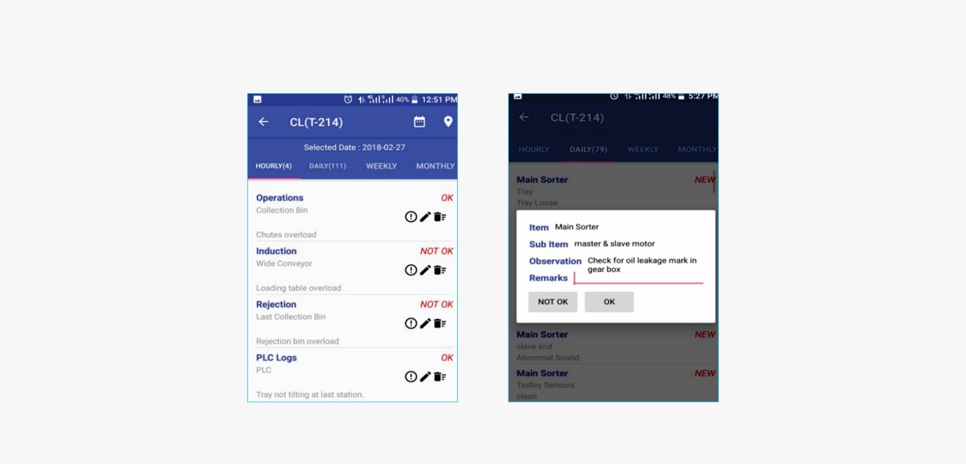

Predictive Maintenance
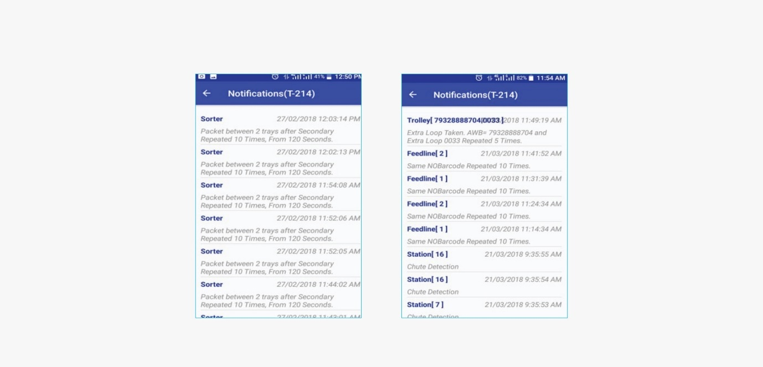

Training Portal
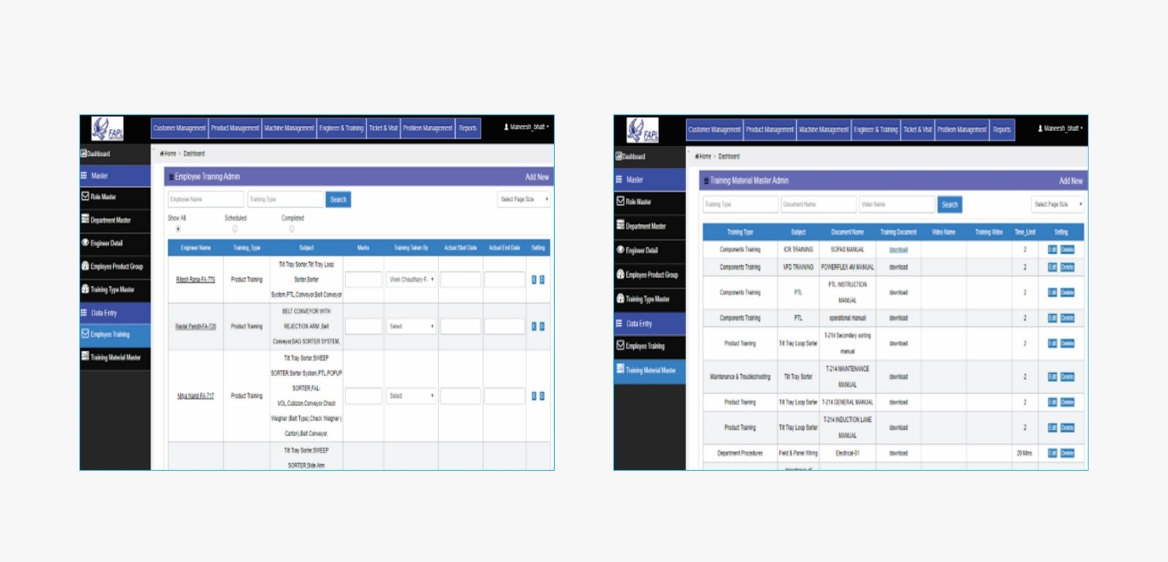

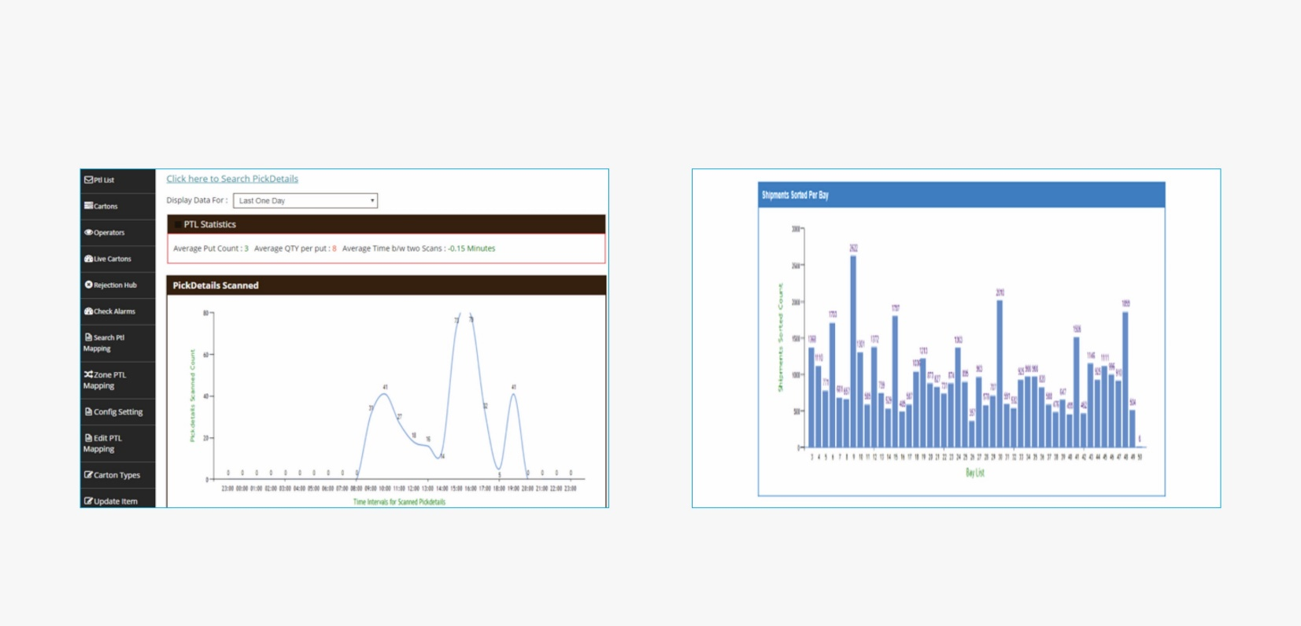
Operational Analysis

Commercial Terms

Price Sheet
Sr. No | Component | Qty | Price (USD)
1 | Pop Up Sorter | 1 | $ 38,462
2 | Conveyors | 1 | $ 1,91,089
3 | Toolkit | 1 | $ 462
4 | Packaging & forwarding | 1 | $ 9,578
5 | Project Management and Engineering Charges | 1 | $ 5,990
Total USD (Excluding Taxes) |  |  | $ 2,45,579

The Total Price is to be understood
- Ex Works – Greater Noida, India
- Freight charges shall be extra at actual
- Taxes will be charged extra: As applicable
- Including Packing and Forwarding
- Duty unpaid
- Installation and Commissioning: Excluded
- Price is valid for 60 days from the date of proposal
Our Price does not include taxes, and duties, import duties, charges, fees, taxes etc. charged by authorities outside India for deliveries and services. Same shall be borne & paid by client itself.
*Material Unloading & Laydown area is in customer scope

Payment Terms
The Supplier Quotation is based on the following payment schedule:
Stage 1: 50% Advance along with PO
Stage 2: 50% + Taxes before dispatch of the material.

Delivery schedule.
Will dispatch material in 16 to 18 weeks. Transit time will be extra.

Warranty Period
Falcons offered System comes with a standard warranty of 1 year (Starts from the date of beneficiary use) and post completion of warranty, customer can opt for Extended warranty. Warranty covers the following support:
- 24 X 7 Telephonic, Email and Remote Service Support when required
- Regular Software updates and Bug Fixes.
- Supply of Mechanical and Electrical components in case of failure (excluding damages as mentioned in Exclusion Clause)
The warranty does not apply to replacement or repair of:
- Normal wear and tear.
- Consumables.
- Faulty articles continued:
  - Failure to comply with the manufacturer's recommendations (logistics documentation, Technical Information Note, retrofit document) and the rules of the trade.
  - Negligence or abnormal use of equipment.
  - Anomalies produced by an environment of use, storage or transport that does not comply with the specifications or recommendations of Falcon: packaging, temperature, hygrometry, sector, insulation, etc.
  - A defect due to a cause external to the supplies and services of Falcon.
- Equipment other than that supplied by Falcon.
- Items that can be repaired exclusively by Falcon that have been repaired or attempted repairs other than those carried out by Falcon.
- Items that fail due to normal wear and tear of one or more of its components or whose tamper-evident seals (varnish, strip, etc.) have been broken or whose serial numbers have been removed or modified.
- Items damaged during transport to Falcon due to the use of unsuitable packaging.

Exclusions
The scope of supply includes all parts which are defined in the Supplier’s quotation.

All other parts which are not defined in the Supplier’s quotation do not belong to the Supplier’s scope of supply and are excluded. The following parts are also excluded:

- Construction Power
- Building infrastructure; building structure, doors, fire exits, levelling devices, building extinguisher and fire alarm system, building heating and lighting system.
- Electrical power supply and wiring to the main control cabinets
- UPS for Controls and Drives
- Electrical Power for Installation
- Network Cabling up to the Main Server Rack
- Intermediate wiring to parts which are to be supplied by the Purchaser/others
- Emergency/Uninterruptable power supply
- Fire-alarm and fire protection devices
- Traffic and route markings
- Laydown Area
- Ram protection devices
- Cat walks, bridges, maintenance aisles and platforms- If not specified
- Assembly tools like forklifts and hoisting machines
- All kind of network incl. Local Area Network (LAN/WLAN), exceeding the scope described in Scope of Supply
- Any Kind of Civil work
- Any adjustment of the Supplier’s scope of supply to local rules and regulations
- X-Ray machines
- Roller cages/ Pallets
- Simulation and 3D animation of the sorter system
- Interface with other equipment not specified in this offer.
- Provision of facilities for the control room (furniture, air conditioning, heating, etc.).
- The supply and installation of fencing around the different corridors.
- Any item specifically indicated as not forming part of the subject matter of the Seller's supply in the offer documentation.

